Vol. CLXXI — No. 74,028 | New York City, Friday, October 4, 2026 — $3.00
The Metropolitan Times
COMPLETE COVERAGE OF WORLD AFFAIRS, CULTURE, AND TECHNOLOGY

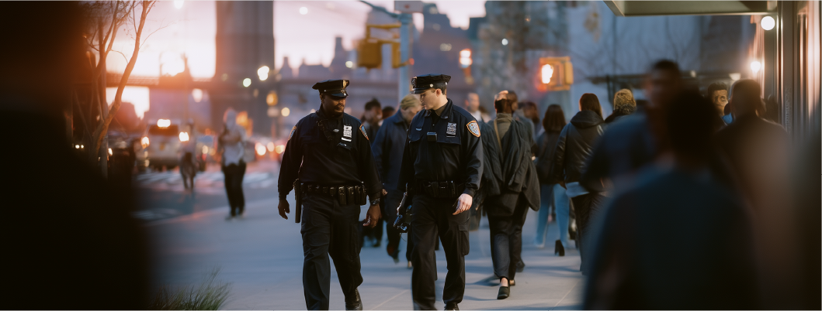
Text about this photo and photographer
URBAN SAFETY REIMAGINED  A New Approach to Public Security |  |  |  |  |  | LOOKING  AHEAD
Across the United States, cities are rethinking what safety truly means. The traditional model of policing — one centered around enforcement and punishment — is being challenged by a wave of community-driven initiatives designed to prevent crises before they happen. From Chicago’s South Side to San Diego’s coastal districts, neighborhoods are experimenting with strategies that combine mental health services, social work, and neighborhood mediation.  At the heart of this movement lies a simple idea: safety is not merely the absence of crime, but the presence of stability, trust, and opportunity. Many advocates argue that investment in education, employment, and social programs can achieve more lasting peace than additional patrol cars ever could.  Community Programs  Taking the Lead  Cities like Denver and Austin have pioneered the deployment of non-emergency response teams composed of mental health professionals, crisis counselors, and trained mediators. These teams respond |  | mediators. These teams respond to incidents that do not require armed intervention — such as disputes, welfare checks, or mental health crises — reducing potential escalation and freeing police resources for critical situations.  Preliminary data shows promising results. Denver’s STAR (Support Team Assisted Response) program handled over 1,300 calls in its first year, none of which required police backup. Reports indicate a measurable decline in minor offenses and improved community relations.  Local governments are also exploring long-term collaboration between community organizations and law enforcement. Grants have been introduced to fund neighborhood watch initiatives that rely on transparency, youth mentorship, and regular dialogue between residents and police departments.  Challenges and Skepticism  Despite growing support, these reforms face substantial obstacles. Funding remains inconsistent, often tied to short-term political agendas |  | rather than sustainable policy. Critics warn that without strong financial backing and institutional reform, community programs risk being reduced to symbolic gestures.  Moreover, some police unions and policymakers express concern that these initiatives may weaken law enforcement authority or fail to respond effectively to violent crime. Balancing public trust with accountability continues to be one of the most complex challenges in modern urban governance.  The Human Element  In cities that have embraced community-led safety, stories of transformation are emerging. In Seattle’s Central District, residents report feeling more connected and empowered after the introduction of neighborhood mediation teams. "When people know each other, they’re less likely to fear each other," says local activist Jordan Nguyen.  Mental health advocates emphasize that this approach not only prevents conflict but also saves lives. By diverting individuals in crisis. |  | Urban planners and sociologists predict that the future of public safety will depend on collaboration between government, technology, and grassroots leadership. Predictive data tools are already being used to identify high-risk areas for violence, while nonprofit organizations work to strengthen community resilience.  As cities continue to evolve, the central question remains: can America build a model of safety rooted not in fear, but in compassion and cooperation? For now, the experiment continues — block by block, neighborhood by neighborhood.  Urban planners and sociologists predict that the future of public safety will depend on collaboration between government, technology, and grassroots leadership. Predictive data tools are already being used to identify high-risk areas for violence, while nonprofit organizations work to strengthen.  As cities continue to evolve, the central question remains: can America build a model of safety rooted not in fear.

Page 2 - October 4, 2026 — $3.00
GLOBAL  AFFAIRS |  | HEALTHCARE SHIFTS  The Dawn of Tailored Treatment |  |  |  | Dr. Laura Benton of Columbia Medical Center explains, “Personalized medicine allows us to move away from one-size-fits-all care toward precision-based outcomes. It’s not just about treating disease — it’s about understanding the patient’s biology in detail.”  How Data Is Redefining  Healthcare  The backbone of this revolution is data — vast, intricate, and constantly expanding. Every patient encounter, from genetic tests to wearable health trackers, contributes to a growing pool of information. Using machine learning, doctors can identify hidden patterns, detect early signs of illness, and even prevent diseases before they develop.  For example, AI-driven diagnostic systems are already outperforming humans in reading X-rays and mammograms. In oncology, personalized treatment plans are improving survival rates by matching therapies to specific genetic mutations in tumors. Meanwhile, cardiovascular specialists use predictive models to calculate an individual’s risk of heart attack years in advance.  The Accessibility Divide  Despite remarkable advances, accessibility to personalized medicine remains uneven. Large hospitals and urban research institutions lead the way, while smaller rural clinics struggle to secure funding for essential equipment and proper staff training.  Dr. Michelle Raynor, director of the Midwest Health Alliance, describes the challenge bluntly: “We have the knowledge to save lives — but not the infrastructure to deliver it everywhere.”
Europe’s energy landscape is transforming as nations accelerate the shift from fossil fuels to renewables. Germany’s rapid expansion of offshore wind farms and Spain’s investment in solar power have positioned the EU as a global leader in clean energy innovation.  Yet the transition isn’t without friction. Rising costs and infrastructure delays have sparked protests in several member states, where residents fear economic instability.  Analysts predict that the next decade will define whether Europe can balance environmental responsibility with industrial strength.  “The ocean is not just rising — it’s swallowing our future”  The world’s oceans are changing at an alarming pace. Recent studies by the Global Marine Institute reveal that sea levels are rising faster than previously projected — a direct consequence of melting ice sheets in Greenland and Antarctica. This acceleration, scientists warn, could reshape coastlines, displace millions, and destabilize economies within the next three decades.  Satellite data shows that low-lying regions, once considered safe, are now at risk. From the flooded streets of Miami to the eroding fishing villages of the Philippines, the signs are unmistakable: water is claiming land once thought permanent. Coastal infrastructure, including ports, highways, and power stations, faces mounting threats, while insurance companies are already reassessing their coverage models in vulnerable zones.  Human Lives on the  Frontline  In Bangladesh, entire communities have been forced to migrate inland as saltwater contaminates farmlands. On small Pacific islands, families debate whether to rebuild or abandon their ancestral and long cherished homes altogether. “The ocean is not just rising — it’s swallowing. |  | A profound transformation is underway in American healthcare. The rise of artificial intelligence, genomic sequencing, and digital health data has ushered in a new era — one where treatment can be precisely designed for each individual rather than applied uniformly across populations. |  | Hospitals and research centers nationwide are embracing what is now called personalized medicine or precision healthcare. Through the decoding of a patient’s DNA and the integration of advanced algorithms, doctors can predict which therapies will be most effective for a specific person.

Text about this photo and photographer

ETHICS, PRIVACY, AND PUBLIC TRUST
The Dawn of Tailored Treatment
 |  | As genetic and biometric data become central to healthcare, ethical questions are intensifying. Who owns the data? How should it be stored, shared, or monetized? Legislators are now drafting new rules to define the boundaries between innovation and individual rights. |  | Bioethicist Dr. Eleanor Marsh warns, “Medical data is more than information — it’s identity. Once shared, it can never be fully reclaimed.”  To maintain public confidence, hospitals are increasingly implementing transparency policies, allowing to opt out of research programs if they wish. |  | As genetic and biometric data become central to healthcare, ethical questions are intensifying. Who owns the data? How should it be stored, shared, or monetized? Legislators are now drafting new rules to define the boundaries between innovation and individual rights.

Page 3 - October 4, 2026 — $3.00
CREATIVITY OR  CALCULATION?  For centuries, art has been defined by emotion, imperfection, and individuality — qualities deeply rooted in the human experience. Artificial intelligence, by contrast, operates through pattern recognition and probability. It learns from data, not from desire.  Critics argue that while AI can reproduce style, it cannot replicate soul. The late art critic Samuel Norris once wrote that “to create is to suffer,” suggesting that creativity is inseparable from human struggle is inseparable from human struggle is inseparable from human struggle. Without consciousness, many believe AI art is imitation without insight — a reflection without reflection. |  | 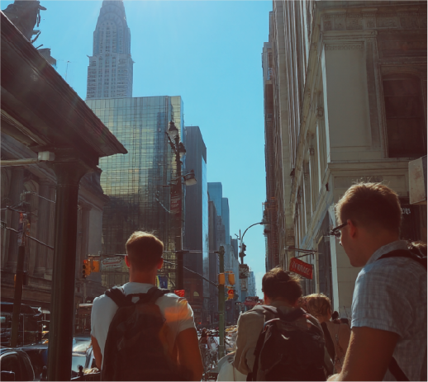  Text about this photo and photographer |  |  |  | DIGITAL  AGE  Once confined to laboratories and code, artificial intelligence has now stepped into the studios, galleries, and concert halls of the world. Algorithms are painting portraits, composing symphonies, and even writing poetry that rivals human expression.  The line between creator and creation has never been blurrier. In recent months, AI-generated artwork has sold for record prices, and digital platforms have become flooded with machine-produced content. What began as an experiment in automation has become a global cultural phenomenon — and a philosophical one as well.  Museums in New York, Paris, and Tokyo are showcasing exhibitions that explore the intersection of human emotion and computational precision. “It’s both exciting and unsettling,” admits curator Amélie Rousseau of the Musée d’Art Moderne. “We’re witnessing a new kind of artist — one that feels nothing, yet creates endlessly.”  Copyright and the Question of Authorship  As AI-generated content expands, legal systems around the globe are struggling to define ownership. If an algorithm produces a novel or a painting, who is the rightful author — the programmer, the user, or the machine itself?  In 2024, a U.S. court ruled that works created solely by artificial intelligence are not eligible for copyright protection, emphasizing that “authorship requires human creativity.” Yet, this decision has sparked further debate. Some artists worry that AI companies could still.
TECHNOLOGY & SOCIETY
The New Artists of the Digital Age
Once confined to laboratories and code, artificial intelligence has now stepped into the studios, galleries, and concert halls of the world. Algorithms are painting portraits, composing symphonies, and even writing poetry that rivals human expression.  The line between creator and creation has never been blurrier. In recent months, AI-generated artwork has sold for record prices, and digital platforms have become flooded with machine-produced content. What began as an experiment in automation has become a global cultural phenomenon — and a philosophical one as well.  “We’re witnessing a new kind of artist — one that feels nothing, yet creates endlessly”  Museums in New York, Paris, and Tokyo are showcasing exhibitions that explore the intersection of human emotion and computational precision. “It’s both exciting and unsettling,” admits curator Amélie Rousseau admits curator Amélie Rousseau admits curator Amélie Rousseau of the Musée d’Art Moderne. “We’re witnessing a new kind of artist — one that feels nothing, yet creates endlessly.” |  | Creativity or Calculation?  For centuries, art has been defined by emotion, imperfection, and individuality — qualities deeply rooted in the human experience. Artificial intelligence, by contrast, operates through pattern recognition and probability. It learns from data, not from desire.  Critics argue that while AI can reproduce style, it cannot replicate soul. The late art critic Samuel Norris once wrote that “to create is to suffer,” suggesting that creativity is inseparable from human struggle. Without consciousness, many believe AI art is imitation without insight — a reflection without reflection.  Supporters, however, see it differently. They argue that AI democratizes creativity by giving access to those who might never have held a paintbrush or studied composition. With simple prompts, anyone can collaborate with algorithms to bring ideas to life, breaking centuries of elitism in the art world.  Copyright and the Question of Authorship  As AI-generated content expands, legal systems around the globe are struggling to define ownership. If an algorithm produces a novel or a painting, |  | who is the rightful author — the programmer, the user, or the machine itself?  In 2024, a U.S. court ruled that works created solely by artificial intelligence are not eligible for copyright protection, emphasizing that “authorship requires human creativity.” Yet, this decision has sparked further debate. Some artists worry that AI companies could still profit from their data — often scraped from online portfolios without consent.  “Machines are learning from us, sometimes without permission,” says digital illustrator Clara Nguyen. “We feed the system with our creativity, and it gives us back something that looks like ours — but isn’t.”

Text about this photo and photographer

Page 4 - October 4, 2026 — $3.00
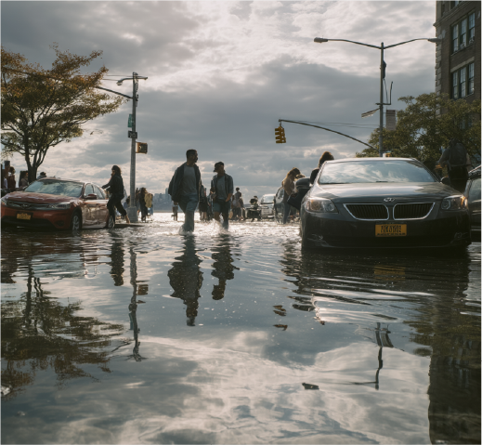  Text about this photo and photographer |  |  |  | driven not by war or poverty, but by environmental collapse.Satellite data shows that low-lying regions, once considered safe, are now at risk. From the flooded streets of Miami to the eroding fishing villages of the Philippines, the signs are unmistakable: water is claiming land once thought permanent. Coastal infrastructure, including ports, highways, and power stations, faces mounting threats, while insurance companies are already reassessing their coverage models in vulnerable zones.  The Science of Acceleration  In Bangladesh, entire communities have been forced to migrate inland as saltwater contaminates farmlands. On small Pacific islands, families debate whether to rebuild or abandon their ancestral homes altogether. “The ocean is not just rising — it’s swallowing our future,” says climate activist Alani Tevita from Tuvalu.  These aren’t distant scenarios; they are daily realities for millions. The human cost of rising seas extends beyond displacement — it includes the loss of culture, heritage, and identity. Sociologists call it climate migration without borders, a new kind of exodus driven not by war or poverty, but by environmental collapse.  Global Cooperation or Global Failure  The upcoming United Nations Climate Assembly in Lisbon aims to address these escalating risks. Delegates are expected to |  | THE ROAD  AHEAD  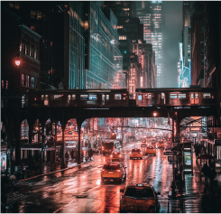  Text about this photo  and photographer  Despite grim forecasts, signs of progress exist. Countries like the Netherlands are leading with innovative flood defenses, including floating neighborhoods and adaptive architecture. In Indonesia, engineers are constructing mangrove walls to slow erosion, while U.S. cities like New York and Boston are redesigning and actively modernizing waterfronts to withstand future storms.  Still, experts stress that adaptation alone is not enough. “Mitigation and resilience must go hand in hand,” says oceanographer Dr. Isabelle Moreau.  “If we treat rising seas as tomorrow’s problem, we will wake up to find tomorrow already here”
CLIMATE REPORT
A Global Emergency Beneath the Waves
The world’s oceans are changing at an alarming pace. Recent studies by the Global Marine Institute reveal that sea levels are rising faster than previously projected — a direct consequence of melting ice sheets in Greenland and Antarctica. This acceleration, scientists warn, could reshape coastlines, displace millions, and destabilize economies within the next three decades.  Satellite data shows that low-lying regions, once considered safe, are now at risk. From the flooded streets of Miami to the eroding fishing villages of the Philippines, the signs are unmistakable: water is claiming land once thought permanent. Coastal infrastructure, including ports, highways, and power stations, faces mounting threats, while insurance companies are already reassessing their coverage models in vulnerable zones.  Human Lives on the  Frontline  In Bangladesh, entire communities have been forced to migrate inland as saltwater contaminates farmlands. On small Pacific islands, families debate whether to rebuild or abandon their ancestral homes altogether. “The ocean is not just rising, it’s swallowing our coastlines” |  | “The ocean is not just rising — it’s swallowing our future”  future,” says climate activist Alani Tevita from Tuvalu.  These aren’t distant scenarios; they are daily realities for millions. The human cost of rising seas extends beyond displacement — it includes the loss of culture, heritage, and identity. Sociologists call it climate migration without borders, a new kind of exodus
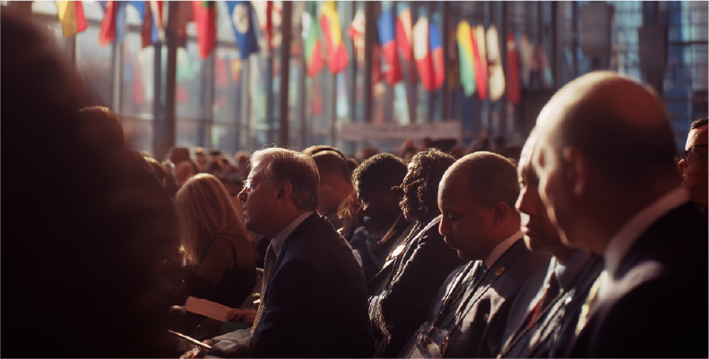
Text about this photo and photographer

